Review Before Printing Affidavits
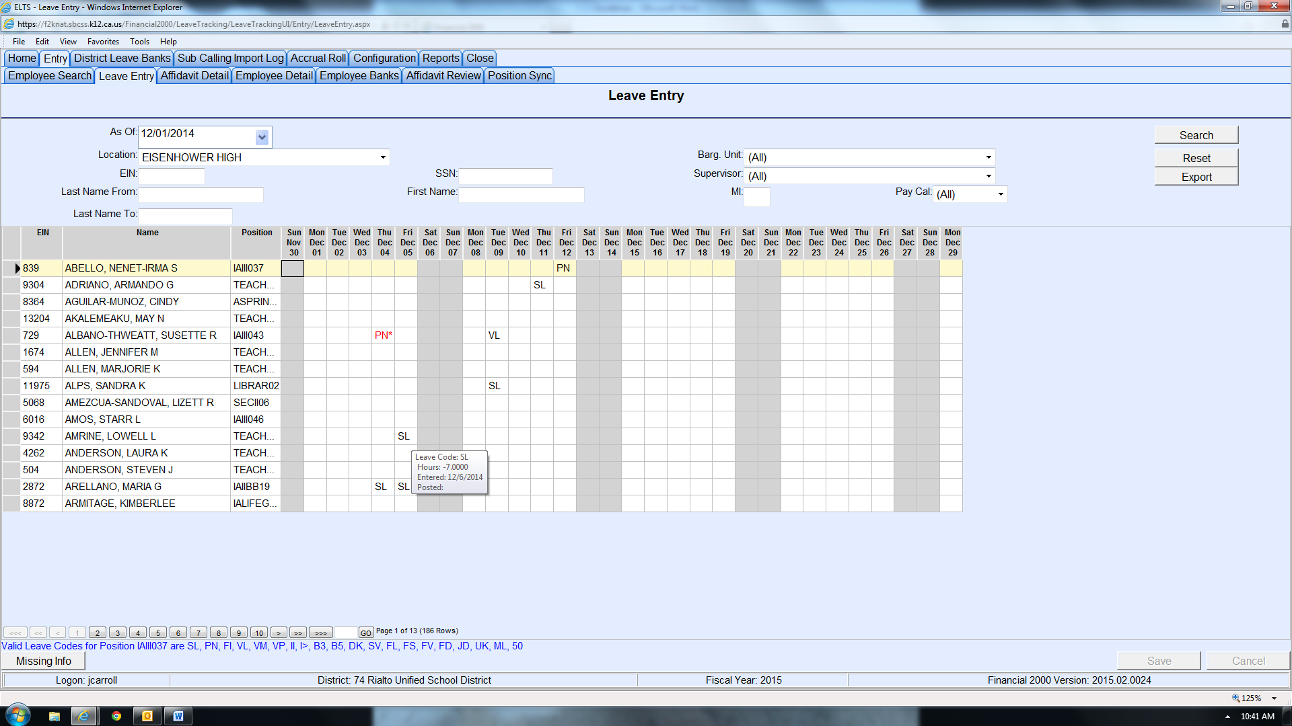
Rounding to nearest quarter of hour:
.00 - .12 = .00 down
.13 - .37 = .25
.38 - .62 = .50
.63 - .87 = .75
.88 - .95 = .00 up
- Review the prior week’s absences by glancing over the “grid” on Leave Entry page by page. Be sure to review ALL pages.
- Hover over each absence type (i.e. VL, SL, PN, etc.) to verify that the recorded times are rounded to the nearest ¼ of an hour. For example -7 instead of -6.93. Make changes if needed. (see chart on the right side center)
- Check for leave types in RED which indicates “Warnings” or “Requires Incident Note.” Add Incident Note for Bereavement (xx/xx/xxxx relationship), if required.
- Enter Transaction Notes (sub’s name, in-house coverage, or FMLA) if needed.
- Enter any absences that are missing.
- Now you are ready to print your Affidavits!

